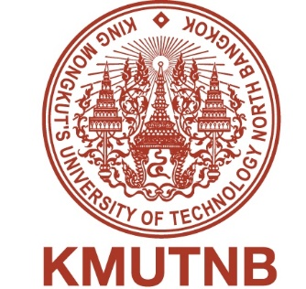
Partner University’s Symbol

MEMORANDUM OF UNDERSTANDING

between

KING MONGKUT’S UNIVERSITY OF TECHNOLOGY NORTH BANGKOK

and

XXXXXXXXX University
--------------------------------------------------------------------------------------------------------------------

King Mongkut’s University of Technology North Bangkok, 1518 Pracharat 1 Road, Bangsue, Bangkok 10800 Thailand, further referred to as KMUTNB
and
XXXXXXXX University, Address

wish to establish cooperative relations between the two Universities, especially to develop academic and cultural exchange between the two Universities in education, research and other areas which agree to the following provisions:

Subject to mutual consent, the area of cooperation includes any program for academic, research, or culture offered at either University in the areas of social science, engineering, technology and others of mutual interest which the two Universities believe cooperation is feasible and desirable, and which would contribute to fostering and developing a mutually beneficial relationship.

Methods

Subject to the approval of the President and/or an authorized representative of each party, this memorandum of understanding shall be carried out through any one or more of the following activities or programs as mutually agreed to by the parties:

- Joint research activities
- Participation in seminars and academic meetings
- Exchange of faculty members and students
- Exchange of academic materials and other information
- Special short-term academic programs such as training courses
- Staff development projects for Masters and Ph.D. programs

The terms of such activities and the budget needed shall be mutually discussed and agreed upon in writing and signed by both parties prior to the initiation of any particular program or activity. Each program or activity shall be negotiated on an annual basis. Each party will designate a liaison person or office to develop and coordinate specific activities and programs.

Effective Date and Length of Agreement

This agreement will remain in force for a period of ……….. (numerial) years. Any amendment and/or modification of this agreement shall require written approval of the President or an authorized representative of each University, and shall be appended hereto. After the initial three ………(numerial) years, this MoU may be extended upon mutual agreement thereafter. This MOU may be revised by mutual written consent. It may be terminated by either Party, at any time provided that the terminating Party gives written notice of its intention at least of six (6) months prior to termination. Activities in progress at the time of termination of this MOU shall allowed to conclude unless otherwise agreed by both parties.

This agreement shall become effective after it is signed by both Universities.

Made in two original copies,

For and on behalf of  King Mongkut’s University of Technology  North Bangkok, Thailand  ________________________________  ………………………………(Name)  President of KMUTNB  Date__________________  ________________________________  ………………………………(Name)  Dean, Faculty of …………………….  Date__________________ | For and on behalf of  XXXXXXXXX University,  Xxxxxx Country  __________________________  ………………………………… (Name)  President of XXXXXX University  Date__________________  ________________________________  ………………………………(Name)  Dean, Faculty of …………………….  Date__________________

